Temporary Parking Permit
Display on front dashboard
FSC Guest
Expires: June 26, 2024
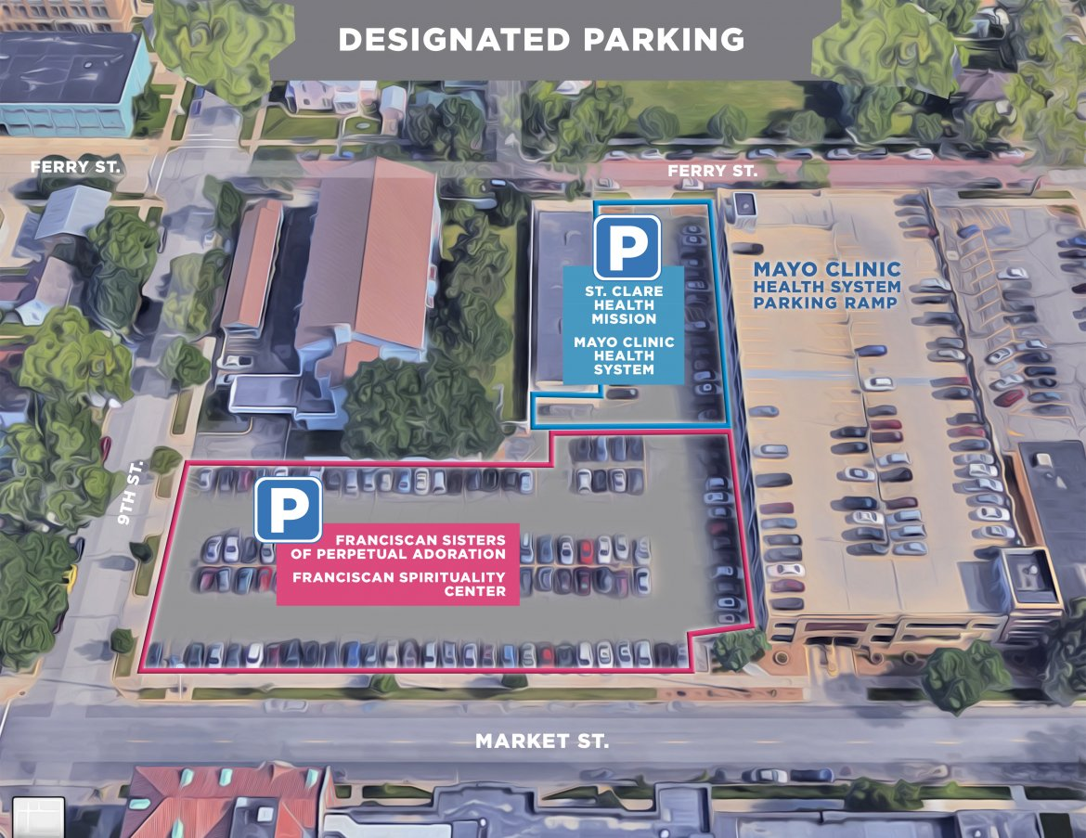
FSPA / FSC

