Temporary Parking Permit
Display on front dashboard
FSC Guest
Expires: July 31, 2024
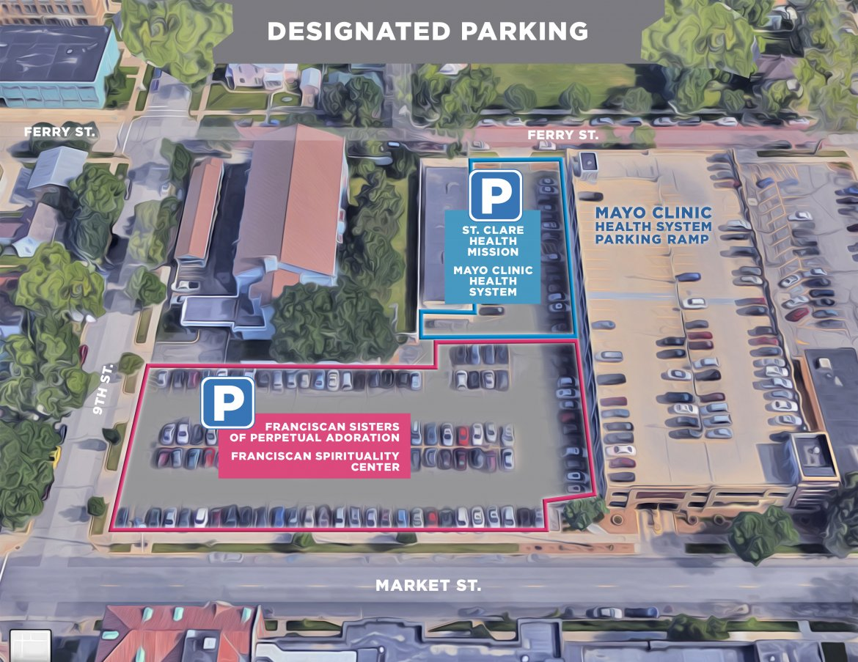
FSPA / FSC

