# 

**LAOSHC Board Meeting Minutes**

Attendees: Eric Bauer, Jen Balfany, Andy Capaul, Kylee Kowalski, Jenny Molstad, Jeremy Johnson, Greg Hoskins

Absent: Tim Kronenbusch, Katie McCabe, Jen Balfany

Meeting was called to order by Eric Bauer at 5:00pm at 1/14/2024

1. President Eric Bauer welcomed all the board members
2. Treasurer Report Jennifer Molstad, RN

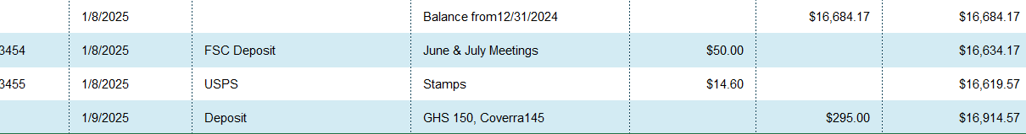

1. **Approval of minutes from December board meeting.** Kylee Kowalski motioned to approve December minutes and Andy Capaul seconded motion.
2. **Schedule of Board meetings:** (meeting held at Three Rivers Bar & Restaurant 5:00 – 6:30)
   1. February 11th
   2. March 11th
   3. April 15th
   4. May 13th

Cost of spirituality center increased but meal cost stayed same Katie will update at next meeting

1. **Schedule of Membership Mtgs.**
   1. Nature Place. 1/28/25. See attached 2025 schedule
2. **LAOSHC website.**
   1. Updates / Changes / Recommendations. Recommendation by Kylee was made to update website after presentations are made or send a copy to members.
   2. Upcoming WSC Training schedule will be updated
   3. WSC Annual Safety Conference (April 14th thru 16th.) Will update website
   4. MN website look into linking MN Safety website link to ours.
      1. Do we sponsor registration for one or two members??
   5. Membership listing

1. **Treasurer report / Membership status for 2025.**
2. **Upcoming training Topics & speakers.**
   1. January 28th – Eric Brown – WC Claims Management Strategies – M3 Insurance
   2. February 25th – Cory White – Small Business EHS – Artificial Intelligence and Technology Tools for EHS Professionals.
   3. March 25th – Chris Halverson – Rick Management – Disaster Response – M3 Insurance
   4. April 29th – No meeting – WSC conference
   5. May 27th - Safety Awards and Scholarship presentations.
   6. June 24th. – Robert Tenhagen – Safety Culture – M3 Insurance
   7. July 29th - Ben Bella – Eau Claire Energy Cooperative – Trust. (Tentative)
   8. August 26th. **NOTE: Possible round table discussion?? Brian possible speaker**
   9. September 30th – Open Round Table
   10. October 28th. – DOT update
   11. November 25th. Annual Meeting – No speaker. OSHA log Mary Bauer
3. **Review of LAOSHC chapter by-laws changes. Will review at next meeting**
4. **Membership drive? La Crosse Area Safety Council Presentation/Conference to promote membership Chamber of Commerce? Will discuss further at next meeting**
5. **General announcements. Reminder to bring business cards to meetings Eric Bauer is taking new position and is going to step down and will be passing his role to Tim Kronenbusch**
6. **Open Discussion Will review bylaw changes at next board meeting.**